LABYRINTHS IN MANUSCRIPTS PORTUGUESE VISUAL TEXTS
Tuesday, February 28, 2017 at 6:00pm
Kresge Room 114, The Barker Center - 12 Quincy Street, Cambridge

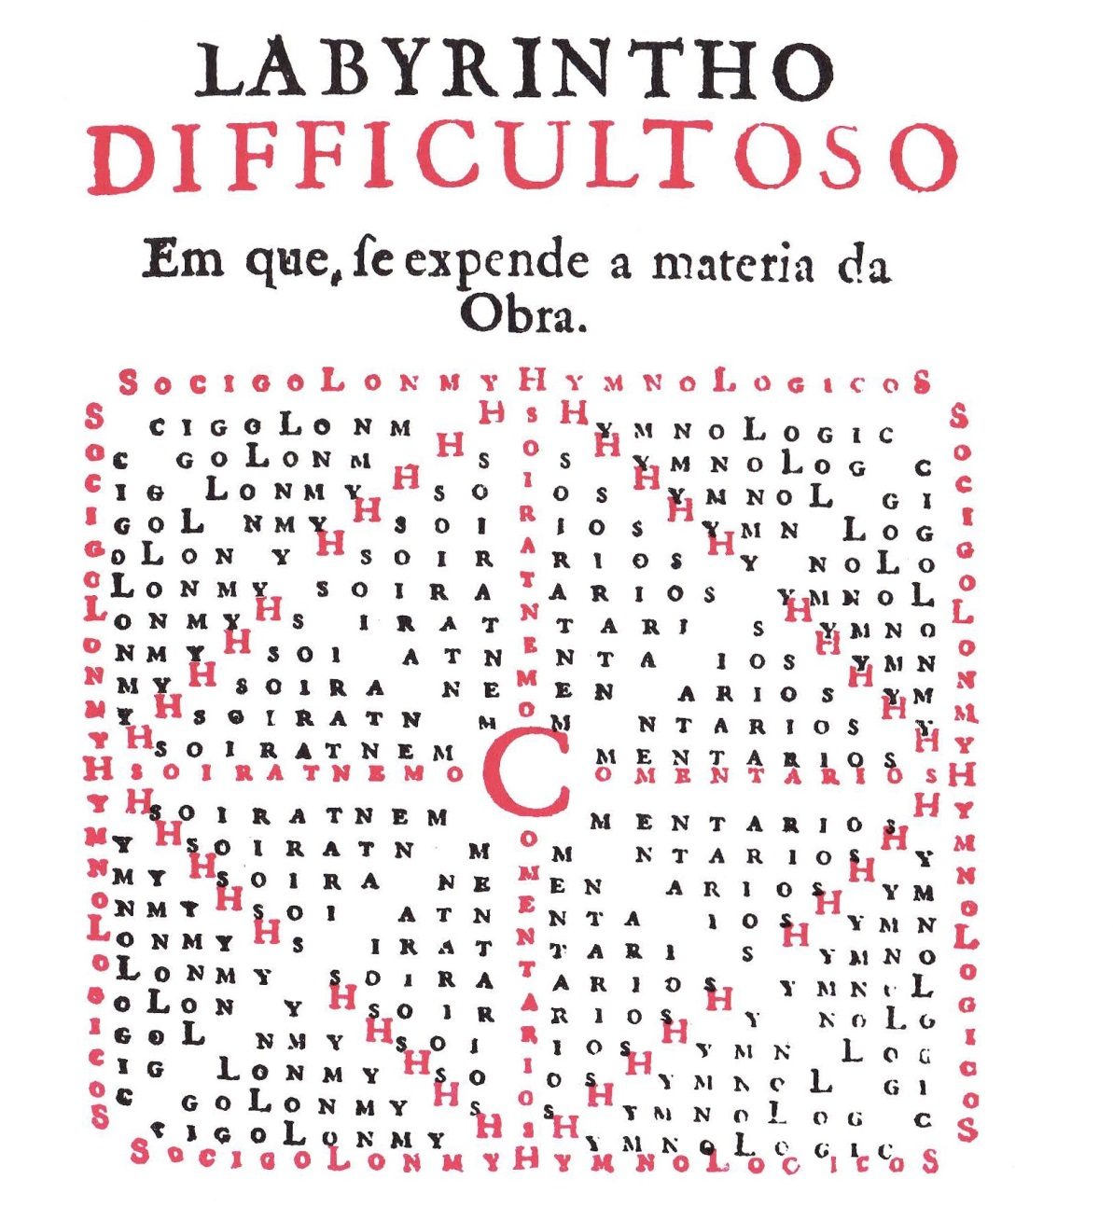
DR. BRUNO C. DUARTE
Universidade Nova de Lisboa --- Johns Hopkins University
Sponsored by the Department of Romance Languages and Literatures

