Friday, April 4, 2014 –OPENING RECEPTION – 7:00 – 9:00 pm

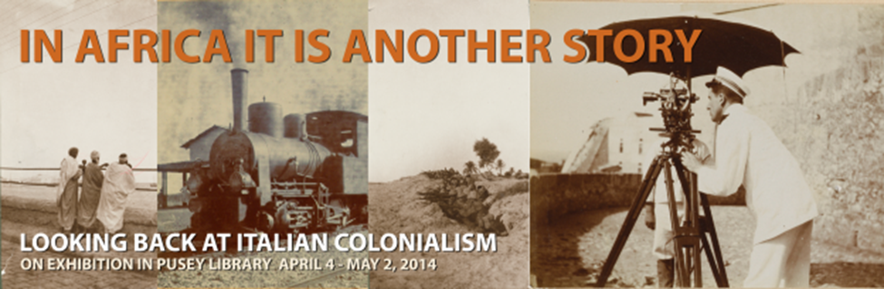

OPENING RECEPTION FOR IN AFRICA IT IS ANOTHER STORY: FRIDAY, APRIL 4, 7-9 PM IN PUSEY LIBRARY. The exhibit features personal albums, photographs, postcards, and maps from the Harvard Library collections ranging from the early twentieth century to the Fascist period. Curated by Professor Giuliana Minghelli and Italian Doctoral candidates Matt Collins, Dalila Colucci, Eloisa Morra and Chiara Trebaiocchi, In Africa it is Another Story investigates the visual, literary and political imaginary that prepared and accompanied Italy’s belated and violent participation in the colonial “scramble for Africa.” The event is free and open to the public.
In conjunction with the exhibit, Pays Barbare (Barbaric Country) by acclaimed filmmakers Yervant Gianikian and Angela Ricci Lucchi, a newly released film addressing Mussolini’s brutal occupation of Ethiopia, will be screened at the Harvard Film Archive.
Pays Barbare Saturday, April 5 7:15 pm followed by Tourisme Vandale 8:45 pm.
