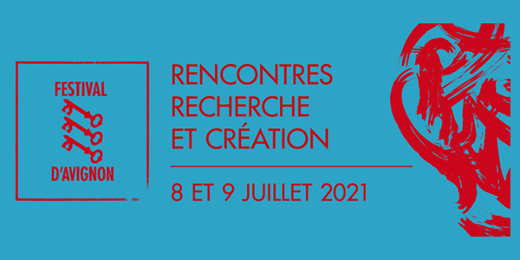

Rencontres Recherche et Création – “La mémoire du futur”
Avignon Festival, July 8-9, 2021

Schedule: https://www.recherche-creation-avignon.fr/
Contact: guyot@fas.harvard.edu
Cloître Saint-Louis in Avignon, France.
Live streaming on YouTube here.
Sign in.

Scholars in literature, history, performance studies, anthropology, sociology, political sciences, philosophy, cognitive science, and neuroscience will exchange views with artists featured in the theater Festival and explore the process of artistic creation, as well as the relationships between making, meaning, affects, and politics.

The Rencontres Recherche et Création are organized by the French Agence Nationale de la Recherche and the Festival d’Avignon — in partnership with: Harvard RLL department, University of Oxford, NYU Department of French, BnF, Centre Pompidou, Université Paris Nanterre, EHESS, CNRS, Collegium de Lyon, Université libre de Bruxelles, University of Avignon, Sacem University, Institut français, IRCAM, Alliance Athena, Philosophie Magazine, L’Histoire, and European Cooperation in Sciences and Technology (COST).

