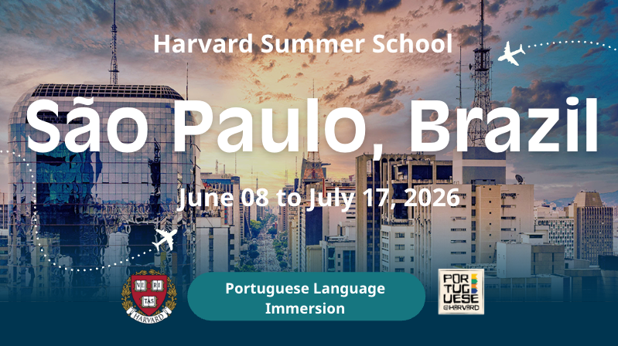

Embark on a six-week journey with us to explore Brazilian struggles for justice, social change, and innovation, and engage with individuals, collectives, and movements fighting to forge a brighter future for Brazil and its people. The program includes a five-day trip to Vale do Ribeira, a region of well-preserved Atlantic Rainforest in the south of the state of São Paulo.

Program Structure
Brazil is much more than samba, soccer, and Rio de Janeiro! The Harvard Summer Program in São Paulo, Brazil will immerse you in Brazilian culture and the Portuguese language. You will explore Brazil's struggles for justice, social change, and innovation while engaging with individuals, collectives, and movements fighting to forge a brighter future for their country and people.

This six-week program counts as one full-year course (8 credits) of degree credit. The program includes daily classes in Portuguese. The program includes numerous guest lectures and experiential field trips, excursions, and activities, including a five-day trip to Vale do Ribeira where you explore the Atlantic Rainforest.
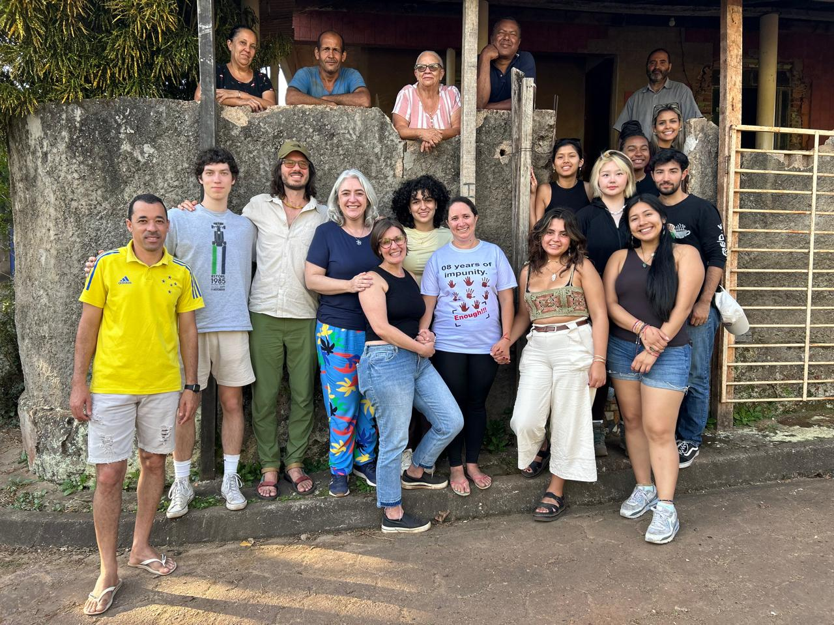
Bento Rodrigues, Minas Gerais

Who can apply?
We welcome applications from undergrad and graduate students enrolled at any accredited university who have an intermediate level of Portuguese. To apply, you have to:
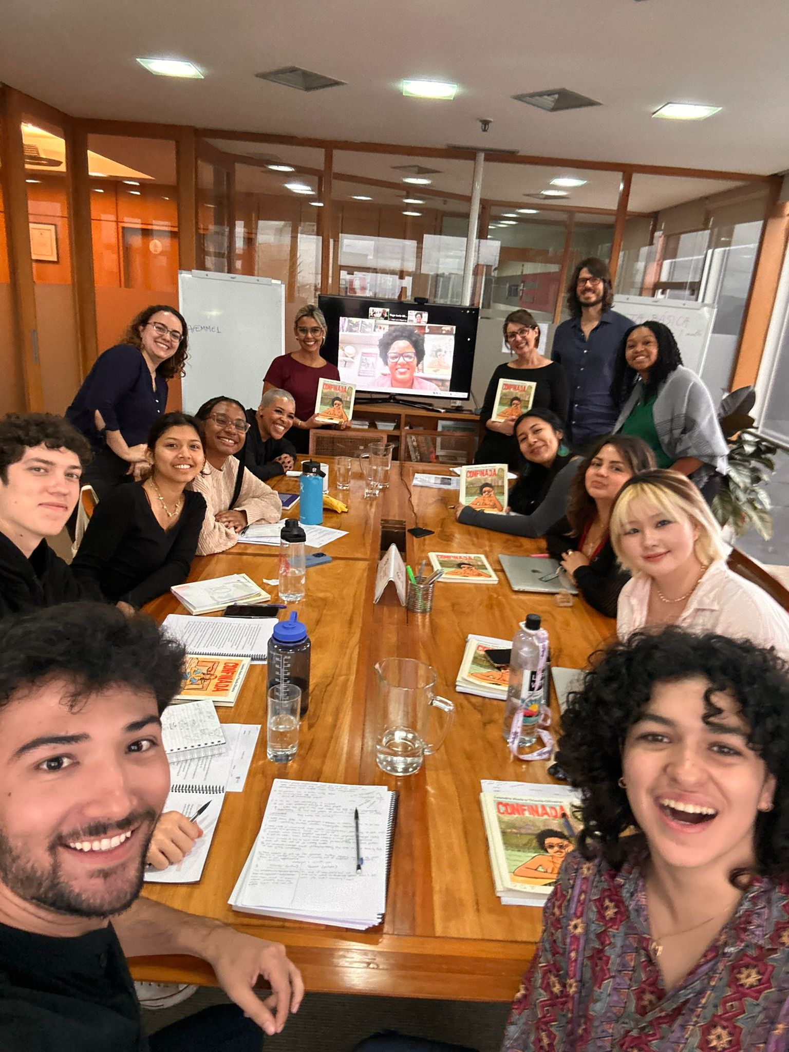
- Be at least 18 years old
- Have completed at least one year of college or be a first-year student
- Have completed at least two semesters (or equivalent) of college-level Portuguese
- Be in good academic standing
Applications from high school students and native speakers of Portuguese will not be accepted.

DRCLAS-Brazil Office in São Paulo

Want to learn more about the program?
- Speak with us directly by attending one of our info sessions:
  - Monday, November 17 at 6 PM at CGIS S216 (1730 Cambridge St, Cambridge, MA)
  - Thursday, December 11 at 5 PM via Zoom
- Find out more about the program, including program daily structure, costs, funding, housing, and application requirements on our website.
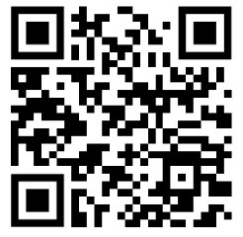
- Sign up to this form and get reminders about important deadlines:
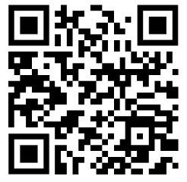
- See some of the exciting places and unforgettable experiences we had in 2024during our visits and excursions: Instituto Terra, Exposição Cláudia Andujar- Inhotim, Parque Estadual do Rio Doce, Museu Afro Brasil.

- Get a better understanding of the program and read what students have to say about their experiences in this presentation.
Come expend an amazing summer in Brazil with us!

If you have questions, please do not hesitate to contact me at cristianesoares@fas.harvard.edu .

We hope to see you in one of our information sessions.

Até mais!

