Special Invitation to Two Special Harvard Events
Tuesday, April 22nd, 2014

11am-12pm -William James Hall #1

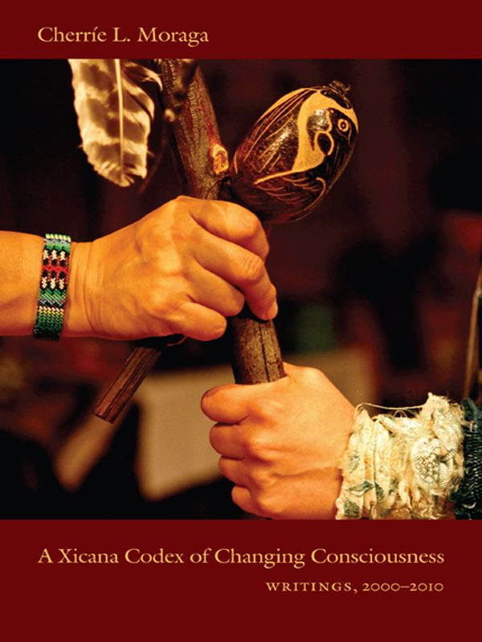
Discussion of Moraga’s new book

A Xicana Codex of Changing Consciousness
Writings, 2000-2010

“This political memoir in essays is a testimony to the awakening of an indigenous consciousness that has been disappeared in the memory of colonized Americas. The collection is blessed by the drawings of Celia Herrera Rodríguez. What a powerful offering in a time of reckoning.” -Joy Harjo, Mvskoke Nation, poet, musician, performer, playwright

6:30pm-8:00pm Harvard Divinity School, Sperry Room
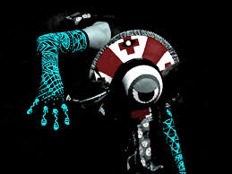
Interactive workshop with
Cherríe Moraga & artist/designer
Celia Rodriguez on their play

New Fire: To Put Things Right Again
Moraga is celebrated as "one of the most influential figures in Chicana/o, feminist, queer, and indigenous activism and scholarship."
Moraga’s plays and publications have received national recognition (United States Artist Rockefeller Felllowship for Literature-2007; a Creative Work Fund Award-2008; a Gerbode-Hewlett Foundation Grant for Playwriting-2009) for their critical and dramatic power to uncover the dynamics of concealment and potential in the lives of women of color. She was co-editor with Gloria Anzaldua of This Bridge Called My Back: Writings by Radical Women of Color (winner of the Before Columbus Book Award in 1986) and author of the now classic Loving in the War Years: Lo Que Nunca Paso por Sus Labios (1983/2003).
Sponsored by: “Latin@s Remaking America: Immigration, Culture and Language” taught by David Carrasco and Maria Luisa Parra, Harvard Divinity School, Department of Anthropology, El Observatorio Cervantes, David Rockefeller center for Latin American Studies, Ethnicity, Migration and Rights, Committee on Degrees of Studies of Women, Gender and Sexuality

