“Brazil beyond the Future”- Lauri Tähtinen History and Literature, Harvard University
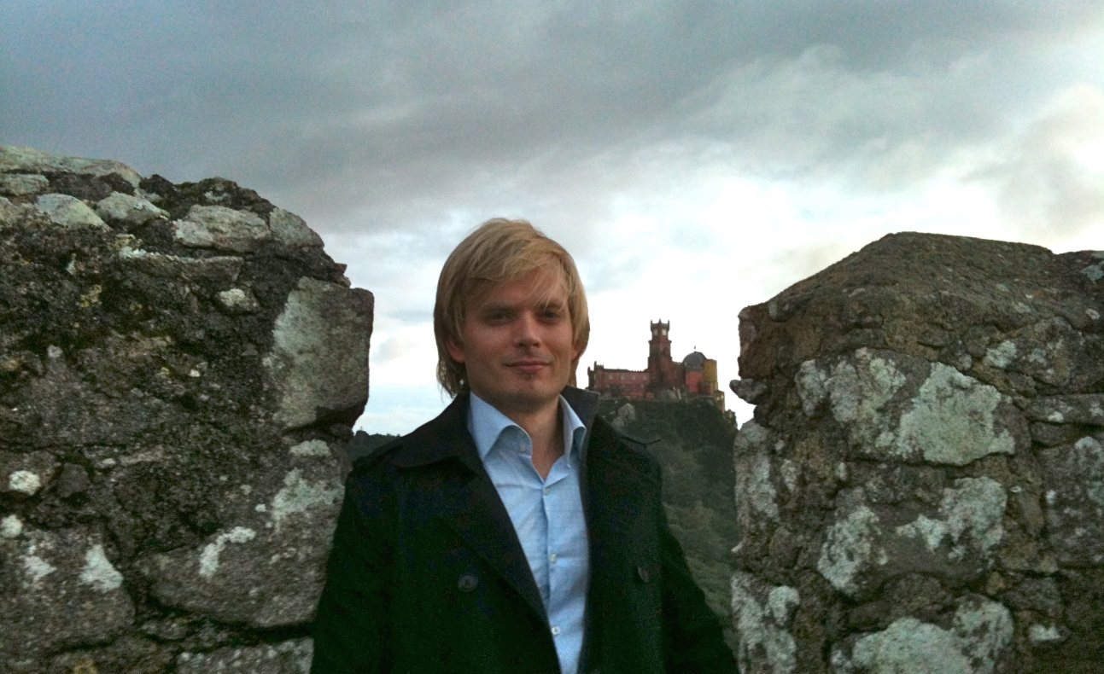
Tuesday, February 24, 2015
5pm to 7pm
Boylston Hall, Room 403

