**Dos Idiomas, Una Comunidad (Two Languages, One Community)**

**April 6, 2017, 4:00PM**

**Harvard Graduate School of Education, Larson Hall**

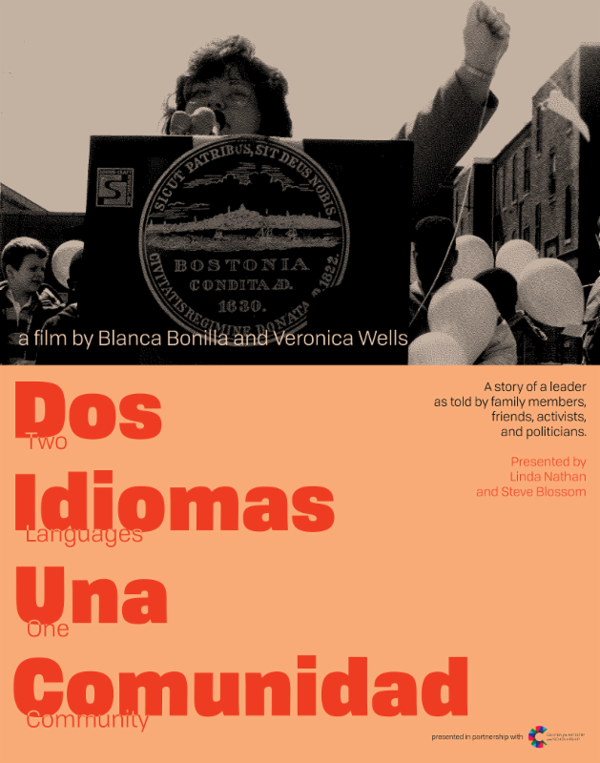

Margarita Muñiz is known in Boston as a champion of integration and bilingual education. Now, thanks to this amazing new film, the world will learn not only of her great accomplishments in Boston public education, but of her amazing life - in Cuba, in an American orphanage, and beyond. This screening will be followed by a Q&A session featuring the filmmakers. [Click here to see the film trailer](https://vimeo.com/188924775)!