France and the World | Verena Conley

Presents

Philip Armstrong

Comparative Studies, Ohio State University

Precarity's Prayers:
On Forms of Political Speech

Monday, March 30, 5pm | 133 Barker Center

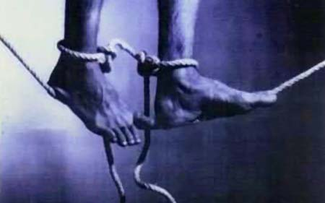

Philip Armstrong has published widely in the area of political theory and contemporary visual arts and culture. Recent publications include Jean-Luc Nancy and the Networks of the Political. He is also engaged in collaborative research projects (Disability, Culture and Human Rights, a Precarity and the Social Contract Working Group as well as another for Research and Creative Activity in the Arts and Humanities).

