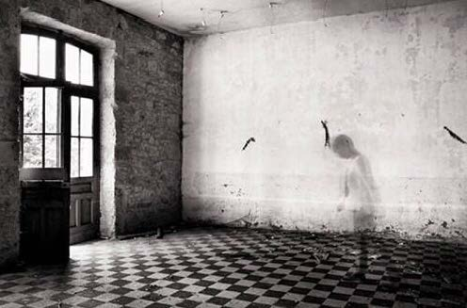
VANISHING VILLAGES, IMMIGRANTS, AND THE REPOPULATION OF “MADRE PATRIA” IN CONTEMPORARY SPANISH LITERATURE, FILM, AND PHOTOGRAPHY
Raquel Vega-Durán (Claremont McKenna College)

Monday, March 27, 4pm, Boylston 335

Sponsored by the Department of Romance Languages and Literatures

